Normal Distributions
The normal distribution, often recognized by its characteristic bell-shaped curve and also known as the Gaussian distribution, plays a surprisingly pervasive and critical role across numerous domains within computer science.
In mathematics, curves can be represented by equations. For example, the equation of the circle is $x^{2}+y^{2}=r^{2}$, where r is the radius. A circle can be used to represent many physical objects, such as a wheel or a gear, the equation and the properties of a circle can be used to study many aspects of the wheel, such as area, velocity, and acceleration. In a similar manner, the theoretical curve, called a normal distribution curve, can be used to study many variables that are not perfectly normally distributed but are nevertheless approximately normal. The mathematical equation for a normal distribution is
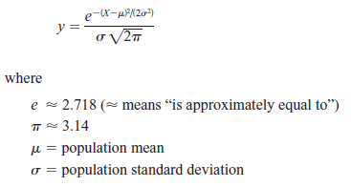
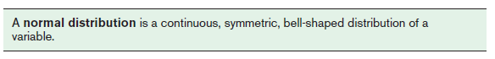
The Standard Normal Distribution
Since each normally distributed variable has its own mean and standard deviation, as stated earlier, the shape and location of these curves will vary. In practical applications, then, you would have to have a table of areas under the curve for each variable. To simplify this situation, statisticians use what is called the standard normal distribution.
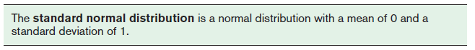
The formula for the standard normal distribution is
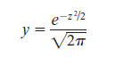
All normally distributed variables can be transformed into the standard normally distributed variable by using the formula for the standard score:
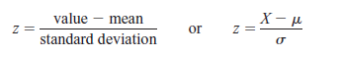

Application of Normal Distribution in Computer Science
There is key applications of the normal distribution in various areas of computer science:
1.Machine Learning
Modeling Error and Noise: In many machine learning models, particularly regression, the errors (the difference between predicted and actual values) are often assumed to be normally distributed. This assumption is crucial for various statistical inference techniques and for calculating confidence intervals for predictions.
Algorithm Assumptions: Several algorithms inherently assume that data or certain parameters follow a normal distribution. For instance, Gaussian Naive Bayes explicitly models the likelihood of features as Gaussian. Linear Discriminant Analysis (LDA) also assumes normally distributed classes with equal covariance.
Anomaly Detection: Normal distribution is fundamental in identifying outliers or anomalies. By fitting a normal distribution to a dataset, data points that fall far from the mean (typically several standard deviations away) can be flagged as unusual or potentially indicative of errors or intrusions
Initialization of Neural Network Weights: While not always strictly normal, initializing weights in neural networks using a distribution centered around zero with a small variance (often related to a normal or truncated normal distribution) can help in effective learning by preventing exploding or vanishing gradients.
2. Algorithm Analysis and Design
Benchmarking and Performance Analysis: When analyzing the average-case performance of algorithms, input data characteristics are often modeled using probability distributions. For certain types of inputs or operations, their distribution might be approximated as normal. This helps in predicting typical execution times and understanding potential bottlenecks.
3. Cybersecurity
Network Traffic Analysis: Normal distribution can be used to model baseline network behavior, such as the volume of traffic, number of connections, or packet sizes over a period. Significant deviations from this established normal behavior can signal an intrusion, a denial-of-service attack, or other malicious activities.
Rules of Finding Area
$1)P\left(Z≤a\right)=φ(a)$ $2) P\left(Z≥a\right)=1-φ(a)$ $3) P\left(a≤Z≤b\right)=φ\left(b\right)-φ(a)$
Example 6-1
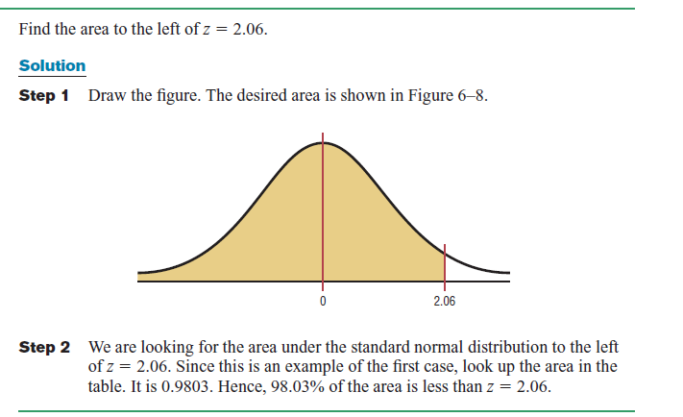
Example 6-2
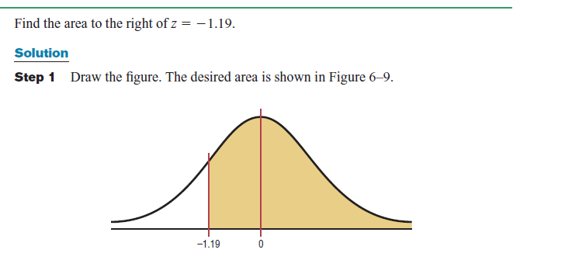
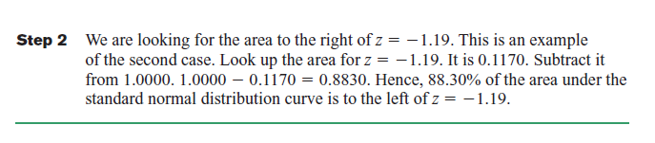
Example 6-3
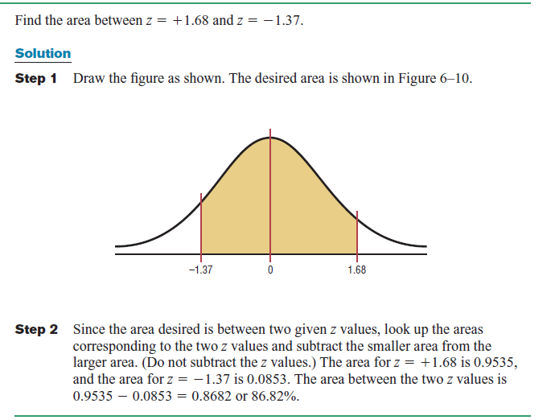
Practice Question
1.System Load Monitoring: Your alerting_subsystem needs to determine the probability that the cpu_load_normalized is between -1.5 and 1.0. If this probability is within a certain range, the system is considered to be in a stable_state_envelope.
2. Latency Spike Detection: A network_monitoring_service tracks the request_latency_normalized for an API endpoint. An alert should be triggered if the normalized latency is unusually high, indicating a potential performance_bottleneck.Calculate the probability that the request_latency_normalized (Z-score) exceeds 2.5.
3. Resource Underutilization Warning: A cloud_resource_optimizer monitors queue_length_normalized for a message broker. A very low normalized queue length might indicate that consumer_processes are idle or that the producer_rate has dropped unexpectedly, leading to inefficient resource allocation. Calculate the probability that the queue_length_normalized (Z-score) is less than or equal to -1.75.

18. Find the area under the standard normal distribution for each.

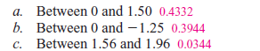
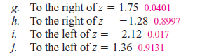

Example 6-3
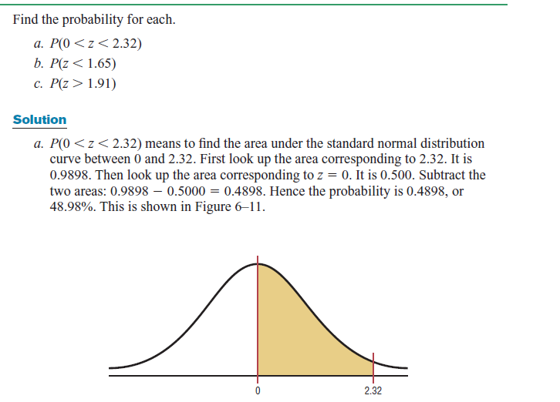
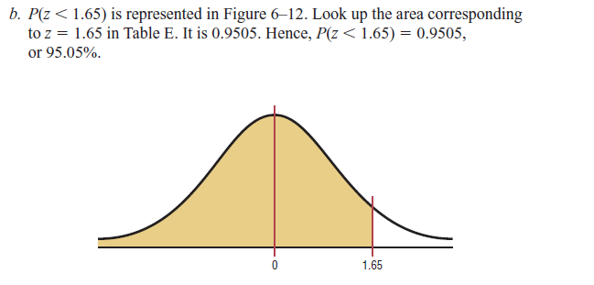
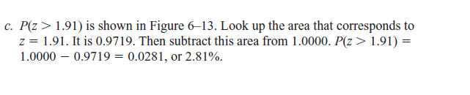
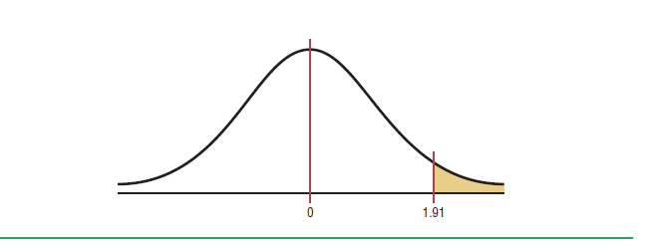
Practice Question
19. Using the standard normal distribution, find each probability.
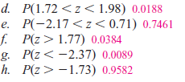

Applications of the Normal Distribution
Question 1
Summer Spending :A survey found that women spend on average $146.21 on beauty products during the summer months. Assume the standard deviation is $29.44. Find the percentage of women who spend less than $160.00. Assume the variable is normally distributed.
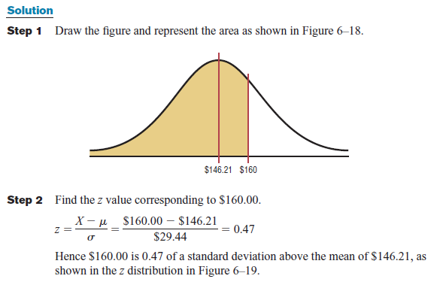
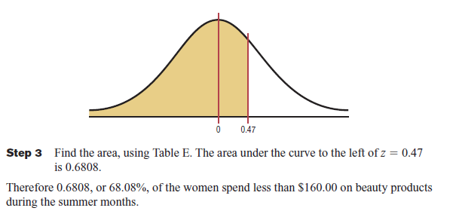

Question 2
Monthly Newspaper Recycling
Each month, a computer science student generates an average of 28 pounds of newspaper for garbage or recycling. Assume the standard deviation is 2 pounds. If a household is selected at random, find the probability of its generating
a. Between 27 and 31 pounds per month
b. More than 30.2 pounds per month
Assume the variable is approximately normally distributed.
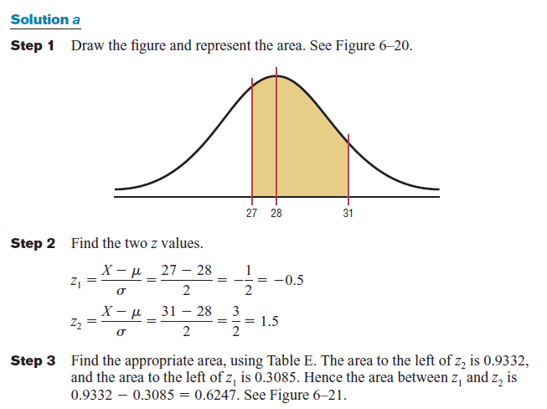
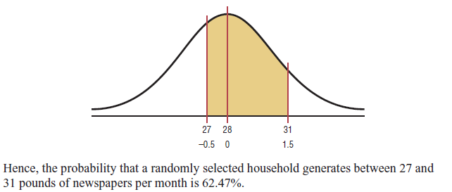
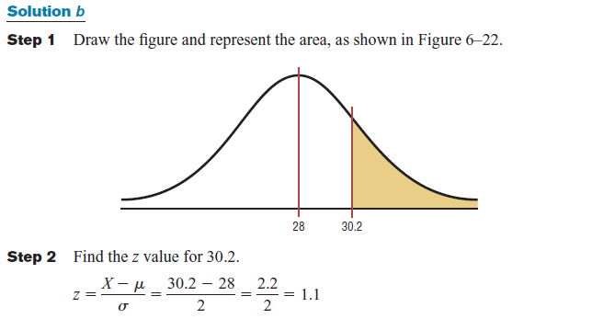
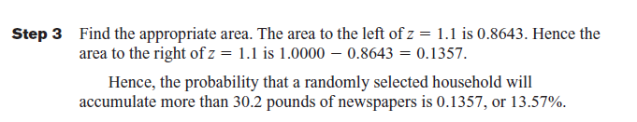
Question 3
Coffee Consumption
Computer science students consume an average of 1.64 cups of coffee per day. Assume the variable is approximately normally distributed with a standard deviation of 0.24 cup. If 500 individuals are selected, approximately how many will drink less than 1 cup of coffee per day?
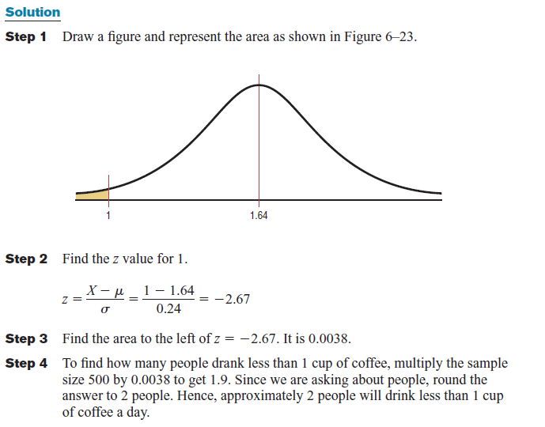
Practice Question
1.API Endpoint Response Time Monitoring:An application_performance_monitoring(APM) system tracks the response time for a critical API endpoint. The average response_time_ms (milliseconds) is 150 ms. The standard_deviation_ms is approximately 25 ms, and the response_times_distribution is approximately normal. Find the probability that a randomly captured api_transaction_log_entry shows a response time that is:
a.More than 160 ms
b.More than 225 ms
c.Between 120 ms and 170 ms
2. Daily User Authentication Failures: A security_analytics_platform records the number of failed user authentication attempts per day for a large enterprise system. The average daily_failed_auth_count is 500. The standard_deviation_auth_fails is approximately 50, and the distribution is considered normal. Find the probability that on a randomly selected day, the number of failed authentications is:
a. More than 525
b. More than 650
c. Between 425 and 575
20. Amount of Rain in a City The average amount of rain per year in Greenville is 49 inches. The standard deviation is 8 inches. Find the probability that next year Greenville will receive the following amount of rainfall. Assume the variable is normally distributed.
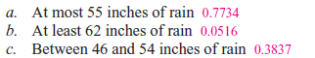

21. Heights of People The average height of a certain age group of people is 53 inches. The standard deviation is 4 inches. If the variable is normally distributed, find the probability that a selected individual’s height will be

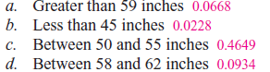

24. Passengers on a Bus On the daily run of an express bus, the average number of passengers is 48. The standard deviation is 3. Assume the variable is normally distributed. Find the probability that the bus will have
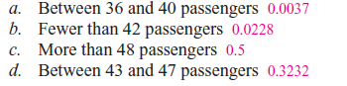
Finding Data Values Given Specific Probabilities
Question no 01:
To qualify for a prestigious tech internship, computer science students must score in the top 10% on a technical aptitude test. The test scores are normally distributed with a mean of 200 and a standard deviation of 20. Find the lowest possible score a student must achieve to qualify.
Solution:
Since the test scores are normally distributed, the test value X that cuts off the upper 10% of the area under a normal distribution curve is desired. This area is shown in Figure below
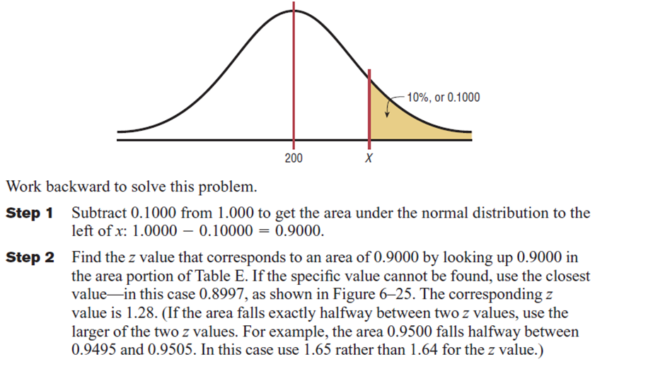
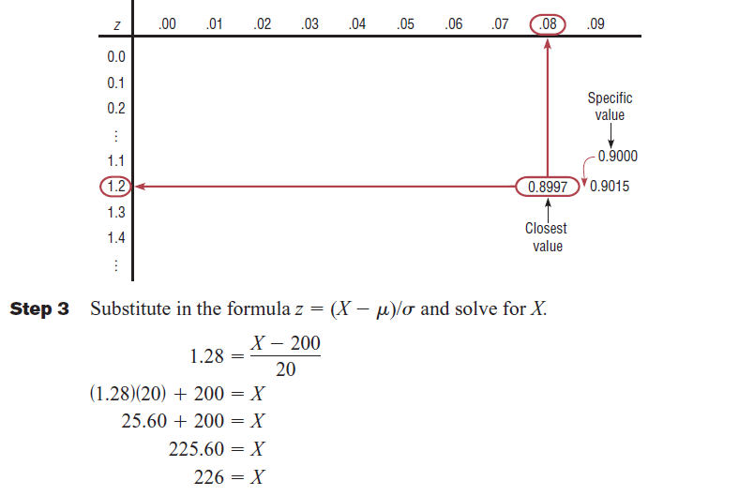
A score of 226 should be used as the cutoff. Any computer science student scoring 226 or higher on the technical aptitude test qualifies for the prestigious tech internship.
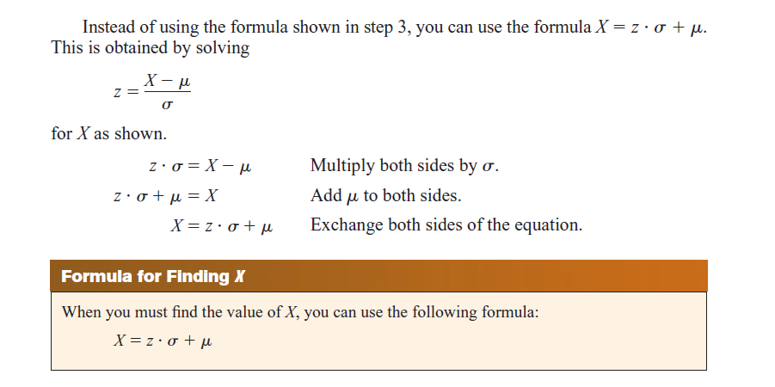
Question no 02:
For a usability research study, a researcher wishes to select computer science students who fall within the middle 60% of the population based on their typing speed.
If the mean typing speed is 120 words per minute (wpm) with a standard deviation of 8 wpm, find the upper and lower typing speed limits that would qualify students to participate in the study.
Solution:
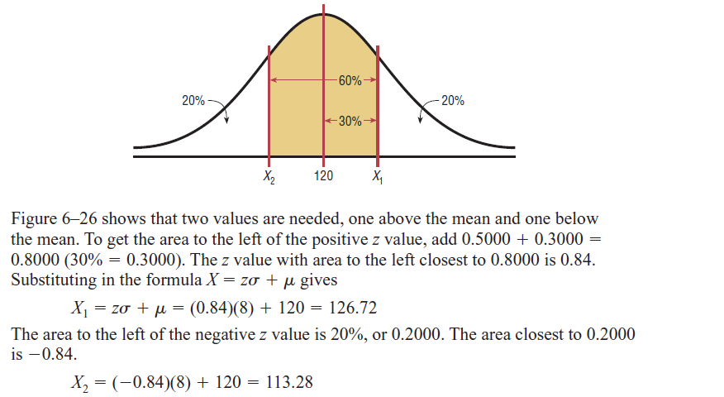
Therefore, the middle 60% of computer science students will have typing speeds between 113.28 and 126.72 words per minute.

Practice Question
1.SAT Scores The national average SAT score (forVerbal and Math) is 1028. If we assume a normal distribution with $σ=92$, what is the 90th percentile score?

2. Suppose X has a normal distribution with mean 25 and standard deviation five. Between what values of x do 68% of the values lie?

3. Two thousand students took an exam. The scores on the exam have an approximate normal distribution with a mean μ = 81 points and standard deviation σ = 15 points.
a. Calculate the first- and third-quartile scores for this exam.
b. The middle 50% of the exam scores are between what two values?

